Problem:

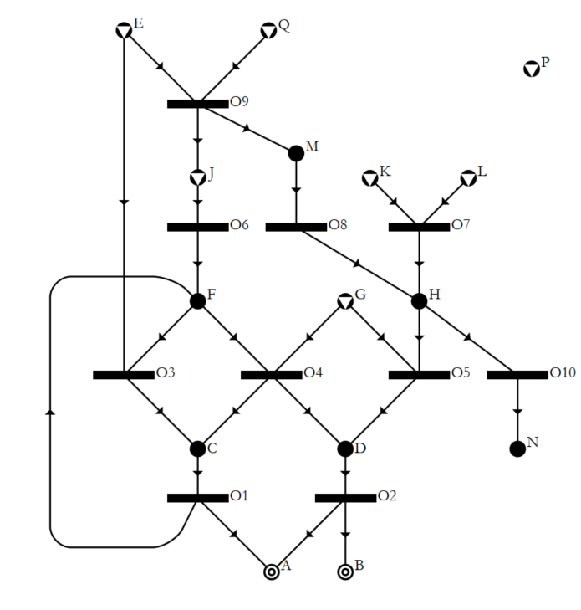
Operating units
Unit | Input | Output | Fixed cost
O1 | C | A, F | 5
O2 | D | A, B | 4
O3 | E, F | C | 8
O4 | F, G | C, D | 7
O5 | G, H | D | 3
O6 | J | F | 5
O7 | K, L | H | 2
O8 | M | H | 9
O9 | E, Q | M, J | 12
O10 | H | N | 1
Raw materials
E, Q, P, J, K, L, G
Desired products
A |  |  | Flow to produce 1

All other materials that are not raw materials or products are considered as intermediate M-type nodes.

Expected results:

Expected output
MSG
O1
O2
O3
O4
O5
O6
O7
SSG:
19 Combinatorially feasible solutions
Expected output ABB:
Best solution (O2, O5,O7) cost: 9
Second best solution (O1, O4) cost: 12
Third best solution (O1, O3) cost: 13

